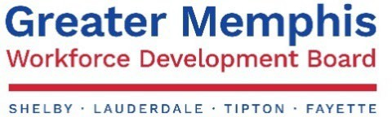

GREATER MEMPHIS LOCAL WORKFORCE DEVELOPMENT BOARD (GMLWDB) GREATER MEMPHIS LOCAL WORKFORCE DEVELOPMENT AREA

## EFFECTIVE DATE: DURATION: POLICY: PURPOSE:

July 1, 2020 Indefinite

Check Request Processing Policy and Procedures

To provide uniform procedures and guidance for ensuring appropriate documentation and payment period.

## Policy

Check Request Processing is a daily responsibility of the Greater Memphis Local Workforce Development Board (GMLWDB Fiscal Staff. Compliance with Federal and State regulations, as well as Governmental Accounting Standards Board (GASB), Generally Accepted Accounting Principles (GAAP) guidelines are required for all documentation and payment request periods.

## Documentation

Appropriate documentation including, but not limited to: provider invoices, time/attendance sheets, paychecks, proof of work performed, and all other necessary supporting documentation must be attached to all check requests.

## Timing

All eligible expenses must fall within the grant contract period permitted by the effective dates and scope of the contract and award used to govern the payment.

## Process and Controls

* Eligibility determination will be initiated by the program area staff. All documentation will be gathered and reviewed for accuracy, as well as the date and contract compliance. When multiple pages of documentation are provided, a summary of charges should be attached to the front of the documentation. The program area manager must review and sign the summary of charges or invoices before being submitted to the Finance Department.
* A Fiscal Tech will then review all supporting documentation to ensure accuracy. This includes, but is not limited to invoice amount, contract service dates, proof of service, and approval signatures.
* The Fiscal Tech will also comply with Uniform Guidance CFR Part 200 to ensure that all costs are reasonable, necessary, and allowable.
* A potentially unallowable cost will be brought by the Fiscal Tech to the Deputy Director of Finance for further review.
* A check request document will be completed with appropriate eligible award numbers assigned for posting and the name of the fiscal team member.
* The Deputy Director of Finance for the Greater Memphis Chamber will review all final documentation and initial for approval.
* The documentation will go to the Executive Director of GMLWDB or her designated approver for final signed approval.
* A check will then be prepared for payment.

# Performance Measure / Accountability

* Periodic monitoring/review will be completed by GMLWDB management to ensure compliance and to make sure the policy is clearly followed.
* Each reported infraction of the policy will be handled on its own merit and may be subject to disciplinary action.

# INQUIRIES

Please contact Amber Covington, Executive Director, [acovington@memphischamber.com,](mailto:acovington@memphischamber.com) with any questions or concerns regarding this policy.

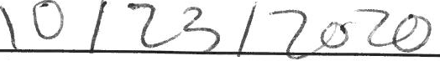

Desi Franklin

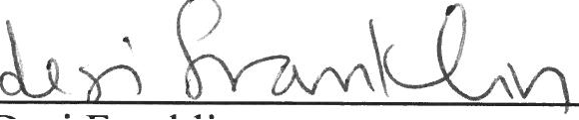

Greater Memphis Local Workforce Development Board, Inc. Board

Adopted Date '

***Greater Memphis Local Workforce Development Board (GMLWDB) is a proud partner of the American Job Center network, is an Equal Opportunity Employer. The Career Center System is an Employer/Equal Opportunity Program.***

***Auxiliary aids and services are available upon request to individuals with disabilities. TTY: 1-800-848-0299.***